CSDO1010 Assignment 2

Paul Krznaric

# Repo:

<https://github.com/PaulKrznaric/yorku-devops-assignment2>

# CLI Proof:

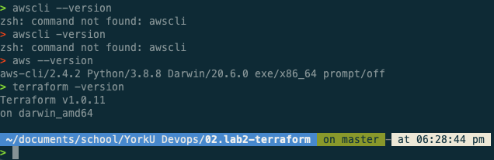

# Terraform Apply Proof:

> terraform apply

Terraform used the selected providers to generate the following execution plan. Resource actions are indicated with the following symbols:

+ create

Terraform will perform the following actions:

# module.compute.aws_instance.webserver will be created

+ resource "aws_instance" "webserver" {

+ ami = (sensitive)

+ arn = (known after apply)

+ associate_public_ip_address = true

+ availability_zone = (known after apply)

+ cpu_core_count = (known after apply)

+ cpu_threads_per_core = (known after apply)

+ get_password_data = false

+ host_id = (known after apply)

+ id = (known after apply)

+ instance_initiated_shutdown_behavior = (known after apply)

+ instance_state = (known after apply)

+ instance_type = "t2.micro"

+ ipv6_address_count = (known after apply)

+ ipv6_addresses = (known after apply)

+ key_name = (known after apply)

+ outpost_arn = (known after apply)

+ password_data = (known after apply)

+ placement_group = (known after apply)

+ primary_network_interface_id = (known after apply)

+ private_dns = (known after apply)

+ private_ip = (known after apply)

+ public_dns = (known after apply)

+ public_ip = (known after apply)

+ secondary_private_ips = (known after apply)

+ security_groups = (known after apply)

+ source_dest_check = true

+ subnet_id = (known after apply)

+ tags = {

+ "Name" = "webserver"

}

+ tags_all = {

+ "Name" = "webserver"

}

+ tenancy = (known after apply)

+ user_data = "da1b5e8dd8879e1c59a5b6ef607e2bb8feb4f1c0"

+ vpc_security_group_ids = (known after apply)

+ capacity_reservation_specification {

+ capacity_reservation_preference = (known after apply)

+ capacity_reservation_target {

+ capacity_reservation_id = (known after apply)

}

}

+ ebs_block_device {

+ delete_on_termination = (known after apply)

+ device_name = (known after apply)

+ encrypted = (known after apply)

+ iops = (known after apply)

+ kms_key_id = (known after apply)

+ snapshot_id = (known after apply)

+ tags = (known after apply)

+ throughput = (known after apply)

+ volume_id = (known after apply)

+ volume_size = (known after apply)

+ volume_type = (known after apply)

}

+ enclave_options {

+ enabled = (known after apply)

}

+ ephemeral_block_device {

+ device_name = (known after apply)

+ no_device = (known after apply)

+ virtual_name = (known after apply)

}

+ metadata_options {

+ http_endpoint = (known after apply)

+ http_put_response_hop_limit = (known after apply)

+ http_tokens = (known after apply)

}

+ network_interface {

+ delete_on_termination = (known after apply)

+ device_index = (known after apply)

+ network_interface_id = (known after apply)

}

+ root_block_device {

+ delete_on_termination = (known after apply)

+ device_name = (known after apply)

+ encrypted = (known after apply)

+ iops = (known after apply)

+ kms_key_id = (known after apply)

+ tags = (known after apply)

+ throughput = (known after apply)

+ volume_id = (known after apply)

+ volume_size = (known after apply)

+ volume_type = (known after apply)

}

}

# module.vpc.aws_internet_gateway.tf_igw will be created

+ resource "aws_internet_gateway" "tf_igw" {

+ arn = (known after apply)

+ id = (known after apply)

+ owner_id = (known after apply)

+ tags = {

+ "Name" = "Terraform-Gateway"

}

+ tags_all = {

+ "Name" = "Terraform-Gateway"

}

+ vpc_id = (known after apply)

}

# module.vpc.aws_route_table.tf_public_route will be created

+ resource "aws_route_table" "tf_public_route" {

+ arn = (known after apply)

+ id = (known after apply)

+ owner_id = (known after apply)

+ propagating_vgws = (known after apply)

+ route = [

+ {

+ carrier_gateway_id = ""

+ cidr_block = "0.0.0.0/0"

+ destination_prefix_list_id = ""

+ egress_only_gateway_id = ""

+ gateway_id = (known after apply)

+ instance_id = ""

+ ipv6_cidr_block = ""

+ local_gateway_id = ""

+ nat_gateway_id = ""

+ network_interface_id = ""

+ transit_gateway_id = ""

+ vpc_endpoint_id = ""

+ vpc_peering_connection_id = ""

},

]

+ tags = {

+ "Name" = "Terraform-Public-RouteTable"

}

+ tags_all = {

+ "Name" = "Terraform-Public-RouteTable"

}

+ vpc_id = (known after apply)

}

# module.vpc.aws_route_table_association.tf_public_assoc will be created

+ resource "aws_route_table_association" "tf_public_assoc" {

+ id = (known after apply)

+ route_table_id = (known after apply)

+ subnet_id = (known after apply)

}

# module.vpc.aws_security_group.tf_public_sg will be created

+ resource "aws_security_group" "tf_public_sg" {

+ arn = (known after apply)

+ description = "Used for access to the public instances"

+ egress = [

+ {

+ cidr_blocks = [

+ "0.0.0.0/0",

]

+ description = ""

+ from_port = 0

+ ipv6_cidr_blocks = []

+ prefix_list_ids = []

+ protocol = "-1"

+ security_groups = []

+ self = false

+ to_port = 0

},

]

+ id = (known after apply)

+ ingress = [

+ {

+ cidr_blocks = [

+ "0.0.0.0/0",

]

+ description = "Allow SSH traffic"

+ from_port = 22

+ ipv6_cidr_blocks = []

+ prefix_list_ids = []

+ protocol = "tcp"

+ security_groups = []

+ self = false

+ to_port = 22

},

+ {

+ cidr_blocks = [

+ "0.0.0.0/0",

]

+ description = "allow traffic from TCP/80"

+ from_port = 80

+ ipv6_cidr_blocks = []

+ prefix_list_ids = []

+ protocol = "tcp"

+ security_groups = []

+ self = false

+ to_port = 80

},

]

+ name = "tf_public_sg"

+ name_prefix = (known after apply)

+ owner_id = (known after apply)

+ revoke_rules_on_delete = false

+ tags = {

+ "Name" = "Terraform-SecurityGroup"

}

+ tags_all = {

+ "Name" = "Terraform-SecurityGroup"

}

+ vpc_id = (known after apply)

}

# module.vpc.aws_subnet.tf_public_subnet will be created

+ resource "aws_subnet" "tf_public_subnet" {

+ arn = (known after apply)

+ assign_ipv6_address_on_creation = false

+ availability_zone = "us-east-1a"

+ availability_zone_id = (known after apply)

+ cidr_block = "10.0.1.0/24"

+ id = (known after apply)

+ ipv6_cidr_block_association_id = (known after apply)

+ map_public_ip_on_launch = false

+ owner_id = (known after apply)

+ tags = {

+ "Name" = "Terraform-Subnet"

}

+ tags_all = {

+ "Name" = "Terraform-Subnet"

}

+ vpc_id = (known after apply)

}

# module.vpc.aws_vpc.tf_vpc will be created

+ resource "aws_vpc" "tf_vpc" {

+ arn = (known after apply)

+ assign_generated_ipv6_cidr_block = false

+ cidr_block = "10.0.0.0/16"

+ default_network_acl_id = (known after apply)

+ default_route_table_id = (known after apply)

+ default_security_group_id = (known after apply)

+ dhcp_options_id = (known after apply)

+ enable_classiclink = (known after apply)

+ enable_classiclink_dns_support = (known after apply)

+ enable_dns_hostnames = true

+ enable_dns_support = true

+ id = (known after apply)

+ instance_tenancy = "default"

+ ipv6_association_id = (known after apply)

+ ipv6_cidr_block = (known after apply)

+ main_route_table_id = (known after apply)

+ owner_id = (known after apply)

+ tags = {

+ "Name" = "Terraform-VPC"

}

+ tags_all = {

+ "Name" = "Terraform-VPC"

}

}

Plan: 7 to add, 0 to change, 0 to destroy.

Changes to Outputs:

+ Webserver-Public-URL = (known after apply)

Do you want to perform these actions?

Terraform will perform the actions described above.

Only 'yes' will be accepted to approve.

Enter a value: yes

module.vpc.aws_vpc.tf_vpc: Creating...

module.vpc.aws_vpc.tf_vpc: Still creating... [10s elapsed]

module.vpc.aws_vpc.tf_vpc: Still creating... [20s elapsed]

module.vpc.aws_vpc.tf_vpc: Creation complete after 22s [id=vpc-01836bc2e34dd6211]

module.vpc.aws_internet_gateway.tf_igw: Creating...

module.vpc.aws_subnet.tf_public_subnet: Creating...

module.vpc.aws_security_group.tf_public_sg: Creating...

module.vpc.aws_subnet.tf_public_subnet: Creation complete after 2s [id=subnet-00f67cfc0bcb1f3ac]

module.vpc.aws_internet_gateway.tf_igw: Creation complete after 3s [id=igw-06b4ad4e4c0e47ad7]

module.vpc.aws_route_table.tf_public_route: Creating...

module.vpc.aws_route_table.tf_public_route: Creation complete after 1s [id=rtb-033d52c10a7aff41e]

module.vpc.aws_route_table_association.tf_public_assoc: Creating...

module.vpc.aws_security_group.tf_public_sg: Creation complete after 4s [id=sg-04199f6e982a28f91]

module.compute.aws_instance.webserver: Creating...

module.vpc.aws_route_table_association.tf_public_assoc: Creation complete after 0s [id=rtbassoc-04f77c4c9e53f52b6]

module.compute.aws_instance.webserver: Still creating... [10s elapsed]

module.compute.aws_instance.webserver: Still creating... [20s elapsed]

module.compute.aws_instance.webserver: Still creating... [30s elapsed]

module.compute.aws_instance.webserver: Still creating... [40s elapsed]

module.compute.aws_instance.webserver: Creation complete after 44s [id=i-00797f4295e848a72]

Apply complete! Resources: 7 added, 0 changed, 0 destroyed.

Outputs:

Webserver-Public-URL = <http://3.91.35.130>

# Cloud Computing Homepage:

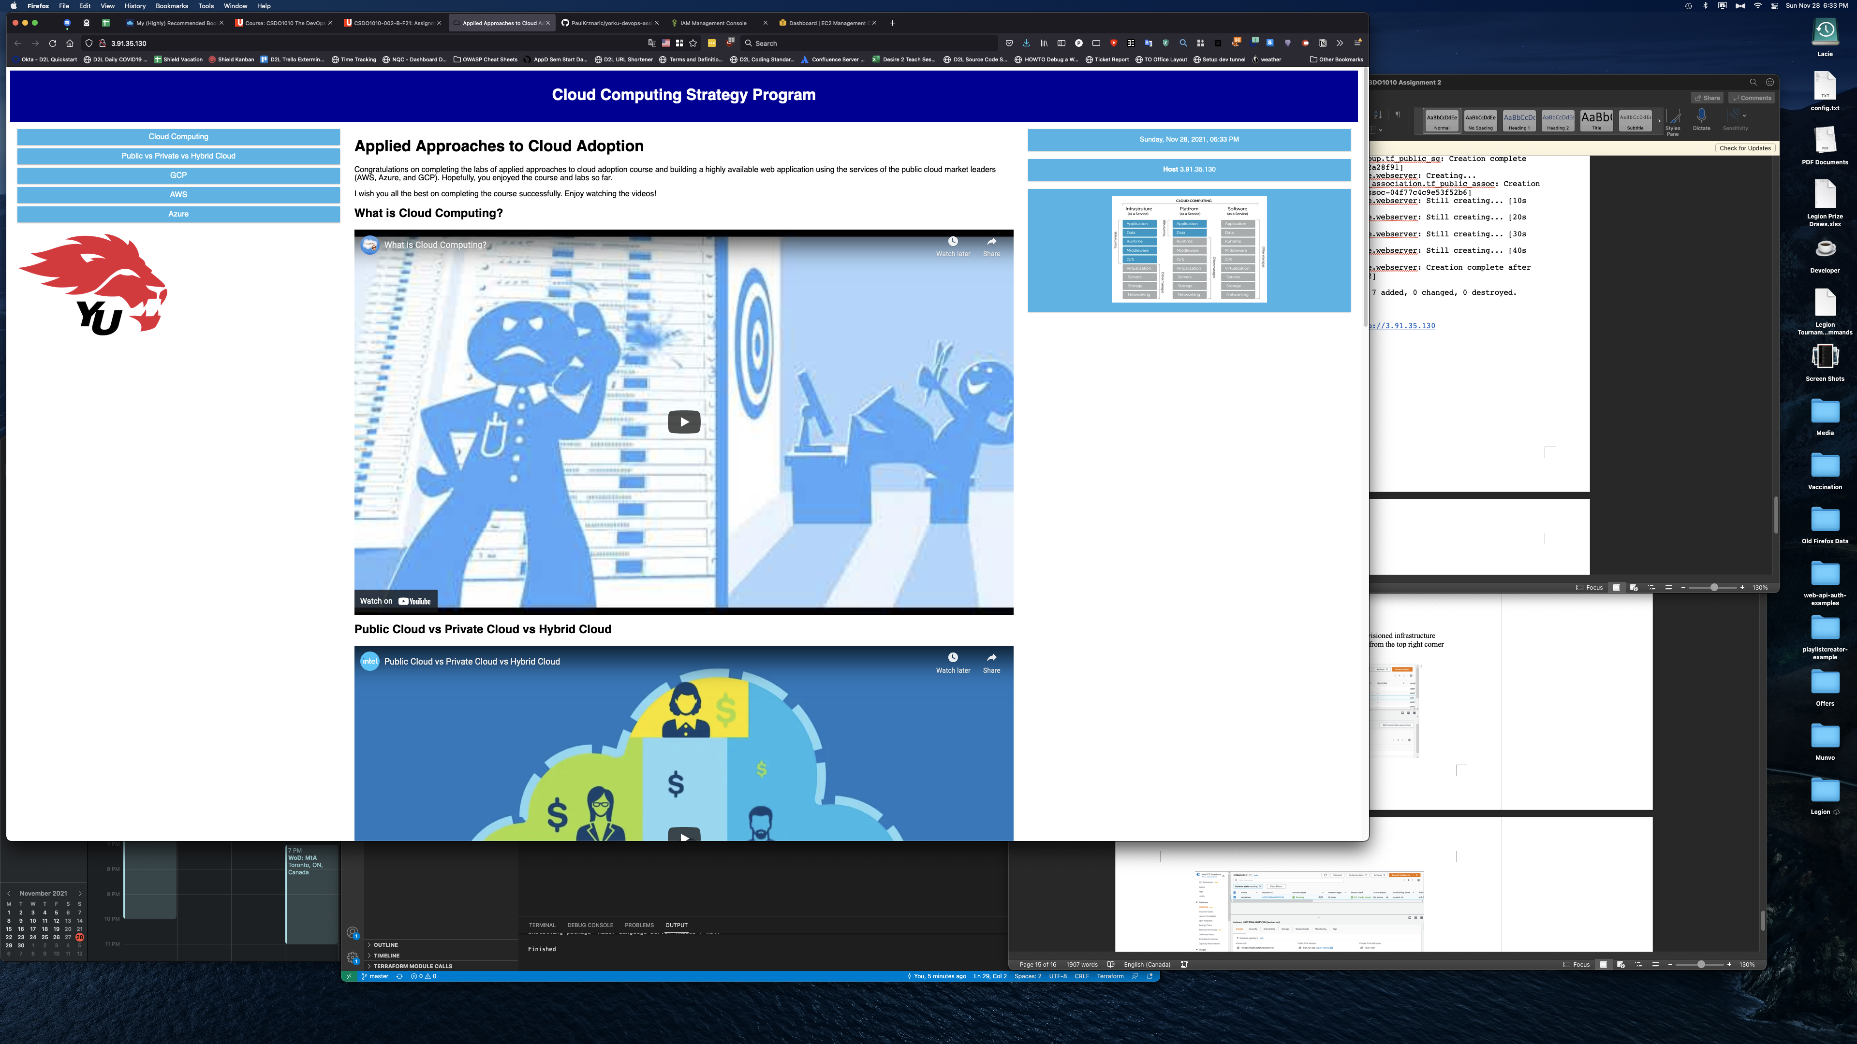

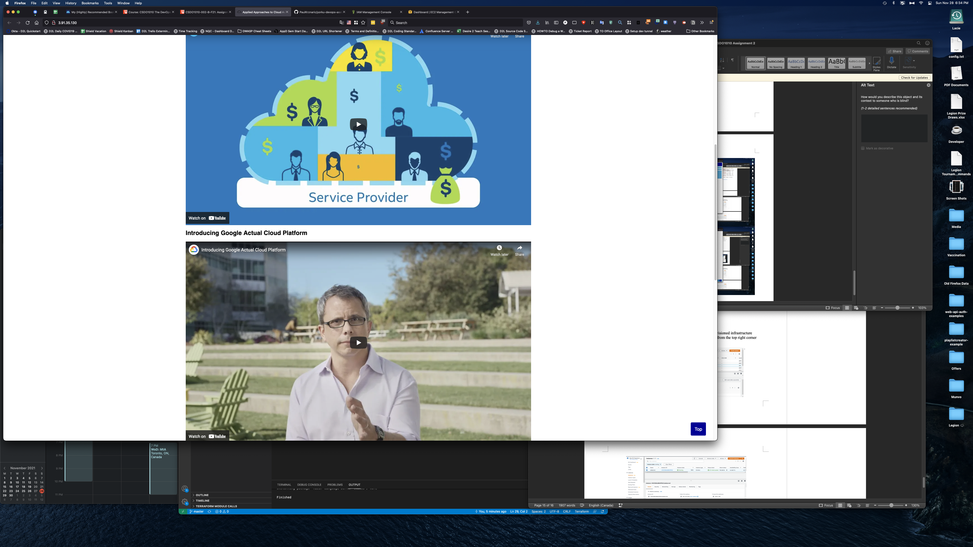

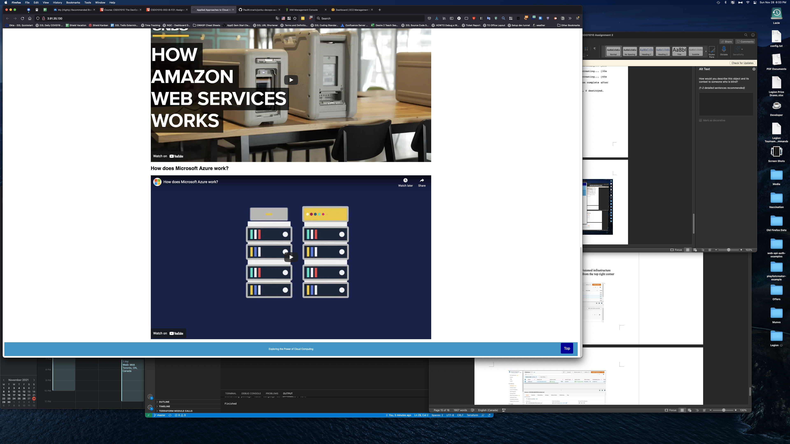

# AWS Instance Running:

